SCIENTIFIC CURRICULUM VITAE
Personal Information
Full Name | Nguyen Tuan Anh | 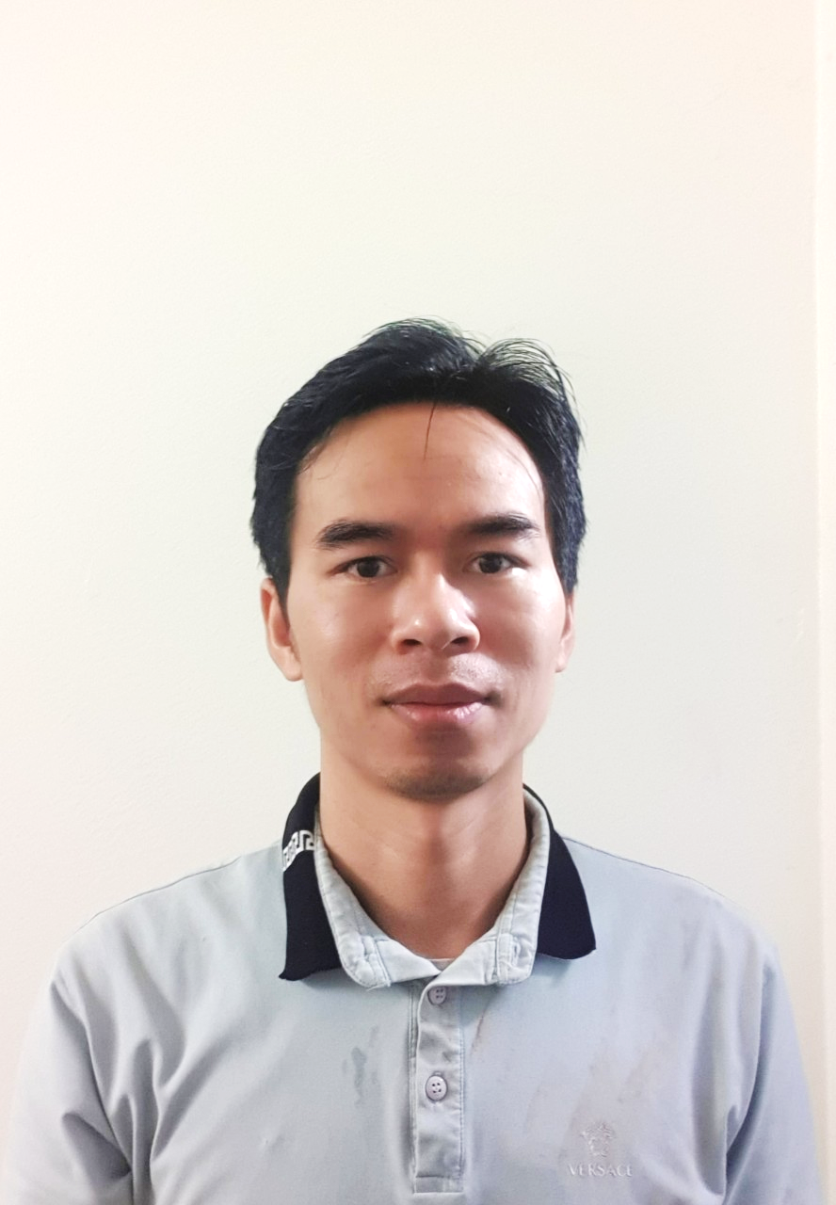
D.O.B | 1981-11-02
National | Vietnam
Scientific Title | Master
Current Position | AI Leader  PhD Researcher
Organization | South China University of Technology, China, Thai Nguyen University of Technology
Scientific Field | Information and Communication Technology
Email | tuananhktmt@gmail.com
Mobile phone | (+84) 0988.086.099

Objective
AI experts

Qualification
# | Degree | Institution | Time
1 | Doctoral | PhD Researcher  South China University of Technology, China  (China’s Government Scholarship/CSC Scholarship)  Major: Information and Communication  Subject:  - Multilingual Code-Switching Automatic Speech Recognition | Since  Sep 2016
2 | Master | University of Information and Communication Technology, Vietnam  Major: Computer Science | 2007-2009
3 | Bachelor | Thai Nguyen University of Technology, Viet Nam  Major: Information Technology | 2000-2005

Academic achievements
 | N. T. Anh et al., “LIS-Net : An end-to-end light interior search network for speech command recognition,” Comput. Speech Lang., vol. 65, p. 101131, 2020, doi: 10.1016/j.csl.2020.101131. | 2020
 | N. Tuan Anh and P. H. Viet, “Toward Speech Keyword Accuracy for String Results,” Int. J. Sci. Res. Publ., vol. 10, no. 06, pp. 413–420, Jun. 2020, doi: 10.29322/IJSRP.10.06.2020.p10248. | 2020
 | N. T. Anh and N. T. Hang, “A new method to display the accuracy of results for each keyword of the KWS model,” Int. J. Eng. Appl. Sci., vol. 7, no. 5, pp. 54–61, 2020. | 2020
 | N. T. Anh, D. T. Hien, and N. T. Hang, “Automatic Multilingual Code-Switching Speech Recognition,” Int. J. Eng. Appl. Sci., vol. 7, no. 5, pp. 47–53, 2020. | 2020
 | N. T. Anh, T. T. N. Linh, and D. T. Hien, “Automatic Multilingual Speech Recognition,” Int. J. Eng. Appl. Sci., vol. 7, no. 5, pp. 41–46, 2020. | 2020
 | N. T. Anh and H. T. K. Dung, “KWA: A New Method of Calculation and Representation Accuracy for Speech Keyword Spotting in String Results,” Int. J. Adv. Comput. Sci. Appl., vol. 11, no. 2, pp. 658–663, 2020, doi: 10.14569/IJACSA.2020.0110283. | 2020
 | N. T. Anh, H. T. T. Hang, and G. Chen, “One approach in the time domain in detecting copy-move of speech recordings with the similar magnitude,” Int. J. Eng. Appl. Sci., vol. 6, no. 4, 2019, doi: 10.31873/ijeas/6.4.2019.05. | 2019
 | N. T. Anh, H. T. K. Dung, and N. T. P. Nhung, “Adaptive Cross-Correlation Compression Method in Lossless Audio Streaming Compression,” Int. J. Eng. Appl. Sci., vol. 6, no. 3, pp. 80–83, 2019, doi: 10.31873/IJEAS/6.3.2019.30. | 2019
 | “One approach in the time domain in detecting copy-move of speech recordings with the same magnitude.”  National conference, application of information technology to reality, Vietnam 2017 | 2017
 | “Adaptive cross-correlation compression method (accm) in lossless audio streaming compression.”  National conference, application of information technology to reality, Vietnam 2017 | 2017
 | Won the 3rd award in “Exhibition for Innovative Products of Science students and young lecturers at the University of Thai Nguyen” | 2012
 | Was awarded with the Certificate of Merit by the Ministry of Education and Training | 2005
 | Won 3rd position and was awarded in National Olympic Informatics | 2003
 | Awarded with the Thai Nguyen University of Industrial Technology Student’s Scholarship | 2002,  2003,  2004

Language Skills
Chinese | Communication, 5 years living in China
English | TOEFL ITP 500, (Reading, Writing, Speaking & Listening)
Vietnamese | Native Language

Job History
# | Position | Workplace | Time
 | Ai Leader | Foxconn Industrial Internet (Hon Hai FuYu) | 2/2022-till date
 | Deep learning Teaching | Online | 2020 till date
 | PhD researcher & Internship | South China University of Technology & GRG Banking equipment | 2016 till date
 | Lecturer | Thai Nguyen University of Technology | 2005 till date
 | Co-Founder & Technical Director | Tam Thai An International Co., Ltd | 2015-2016
 | Co-Founder & Technical Manager | Hoang Lien Automation Co., Ltd | 2008-2014

Research Experience and Achievements
Current research interest in
- Kitting automatic material location – AI-powered material management, material import and export, and interaction with the main system of the corporation
- Kitting-chain automatic working analysis: System to analyze working trends of warehouse and production line workers
- CCD for industrial production line (Using AI to external identification)
- End-to-End Automatic Speech Recognition using Deep Learning
- Head tracking in video for real-time securities
- Image & Video Processing, Forgery Detection, Face Detection, Facial Recognition
- Deep Learning
- Embedded Systems, Microcontroller, Microprocessor
Co-operate Research Experience | Time
- Research visit to Kyungpook National University in DAEGU, South Korea, for 03 months. | 2015
- Working with Germany engineer team in Vietnam for 03 months for building an industrial factory. | 2014

Professional Capacity
- Software/firmware:
Python, Visual C++.NET, C#.NET, VB.NET, PHP, C, C++, Java, MATLAB, Android studio, React Native, Processing, SQL, ASM, Pascal, BASIC, Delphi, VB6, Java/VB script, HTML, ASP, DOS batch, Visual FoxPro, AutoIt, PLC Ladder/ASM
- Hardware:
Arduino, 8051, PIC, AVR and many other electronic components and devices
- Study new things: I can study and learn new things fast.

Some of these years achievements | Time
Completed projects in Foxconn Fii  - Kitting automatic material location – AI-powered material management, material import and export, and interaction with the main system of the corporation  - Kitting-chain automatic working analysis: System to analyze working trends of warehouse and production line workers  - CCD for industrial production line (Using AI to external identification), multi-type of CCD:  - The system recognizes the screw that has been attached to the case  - The system identifies enough and correct components on the foam  - The IC identification system has placed the correct type and position on the packaging mold  - Printed circuit board solder detection and evaluation system  - SCADA for managing and monitoring machines in chain, AR-supported | 2022-till now
From the second year in PhD researcher at SCUT:  - Internship at GRG Banking from 2017 to now. Some projects had done in this time, all of them using Deep Learning:  - Speech Recognition  - Keyword Spotting  - Speech command recognition  - Facial recognition  - Finger vein recognition  - Fingerprint recognition  - Object detection  - Text segmentation  - License plate recognition  - Counting people  - People tracking  - … | From 2017  To now
The first year in PhD researcher at SCUT:  - Successfully tested PCA facial search algorithm. Written into the program.  - Using OpenCV on a Python / Visual C ++ environment, it is possible to write face detection programs, face recognition in the database.  - Learn about Audio forgery, wrote the automatic forgery tool, applied to the copy-move detection algorithm  - Published some SCI, Scopus and International papers, and National Conferences (wrote above)  - Programming some experiment software on Facial Detection and Recognition | 2016

Some projects in history
Project Manager:
- Participate in all facets of a project’s life cycle from design, implementation, testing, documentation and deployment.
- Identify ways to improve workflow processes for efficiency.
- Communicate with customer to clarify requirement, make project plan and manage project progress.
- Adhere to strict delivery schedule with high quality.
- Report project progress, issues, technical solution etc. to Technical Director.
- Support team members on technologies, provide solution decisions.
- Review all project documentation.
- Support Manager on communicating, clarifying, verifying project scope, requirement.
- Provide software proposal, estimation based on project requirement.
- Assign tasks to resources efficiently.

Software Projects
All of them below are my design and implementation, full-stack job
Dynamic train weight and database management software (Uong Bi thermal power company in Quang Ninh)
Car weighing software (Thanh Liem - Ha Nam cement company, Ha Can Steel Trading Company)
Paper test point recognizing software
Image processing software with filter, rotate, crop, resize and some other features (Applicable in the industry)

Embedded System Projects
All of them below are my design and implementation, full-stack job
High speed grinding temperature measurement (2Mbps) using Arduino, USB connection.
Design, manufacture and programmable 5-bar parallel robot, used to optimize motion algorithms
Design, test production, automatic balance system for vertical two-wheeled bicycles
Tilt measurement system of tilt gear in the mechanics.
Circuit design and coding for projects: Belt weighing system (currently being used in many companies)
Real time clock with calendar (include lunar calendar), control bell for schedule time (Using in Universities, such as TNUT, Luyen Kim…)
Design and installation of electric dust filter (2Kw/12Kv)
Loadcell amplifier module, the voltage value displayed on the 7-segment LED (Tien Son – Hanoi cement company, Cao Ngan cement company)
Counting cement bags (Cao Ngan cement company)
Control angle of solar panel
Soft startup module
Synchronous signal from different bus (Built for Nui Phao company, Managed by a German company)

Hardware Projects
All of them below are my design and implementation, full-stack job
Frequency to voltage circuit (F2V): 0...30KHz → 0...10V (high-quality measure speed of motor)
Amplifier integrated circuit module (Repeat: 0...10v → 0...10v / invert: 0...10v →-10v...0v / Shift voltage: 0...10v → -10v...10v/ Multiplier:0...Xmv → 0...10v)
Module coupling, expansion port, communications between PC and ADDA card used in Embedded system like Belt weighing system, PC monitoring.
Voltage power circuit versatile design
- Input: one or two: AC 15v or 0/12v
- Output: -12v, 0v, 5v, 12v, Adjustable

Key Skills
Independent and researching skills
- Teaching: Posses strong teaching/training skills.
- Presentation: Strong presentation skills
- Creative: Can introduce new ideas and/or build on the ideas of others.
- Ability to work for long hours
- Technical: Good at technical skills, technical writing
- Research: Can collect/gather information from many sources such as library, research books and internet to enrich my knowledge.
- Reading documents: Very good at finding and reading relevant documents, reading comprehension of English documents.
- Active: Proactive in nature

Team work skills
I have worked in groups for long time and can recognize that I have been following these skills:
- Communication
- Adaptability
- Collaboration
- Leadership
- Conflict Management
- Patience

Hobbies
Badminton, web surfing, movie…

Thank you for your interest in my CV!

